Afbeelding / image | Credits
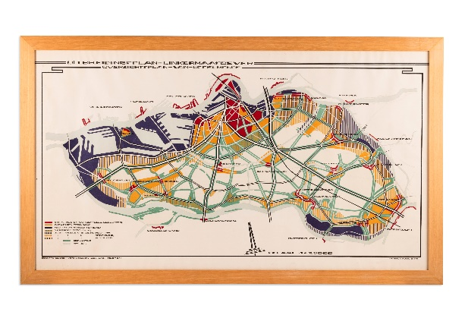 | Grandpré Molière, Verhagen & Kok, Uitbreidingsplan Linkermaasoever, Overzichtsplan van IJsselmonde, (Rotterdam 1921)
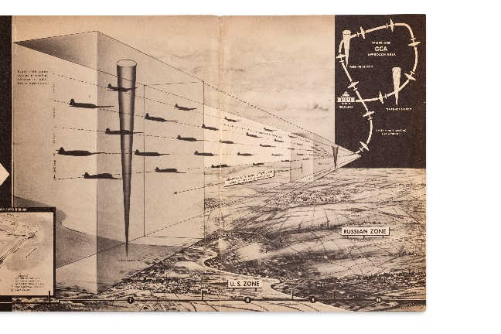 | (Operation Vittles) How the ‘Berlin Airlift’ functions in keeping the ‘Island City’ of Berlin supplied with the necessities of life, z.p. 1949
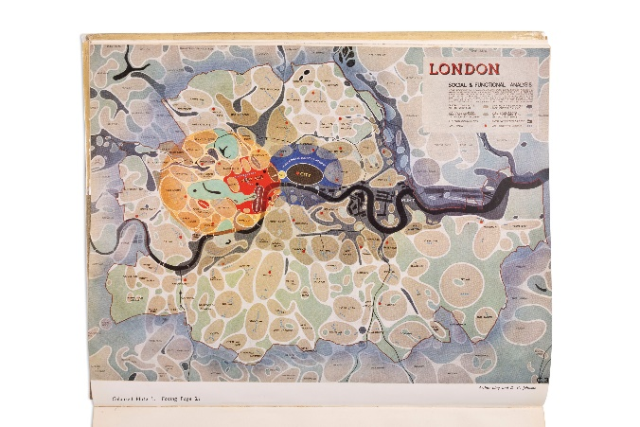 | A. Ling & D. Johnson, London, Social & Functional Analyses, London 1943

