Persmap- Screenwear
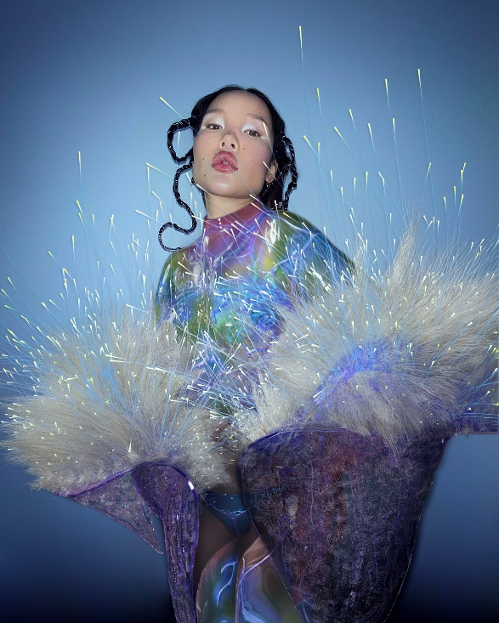 | Auroboros, Atokirina jas en Mandrake bodysuit, 2021
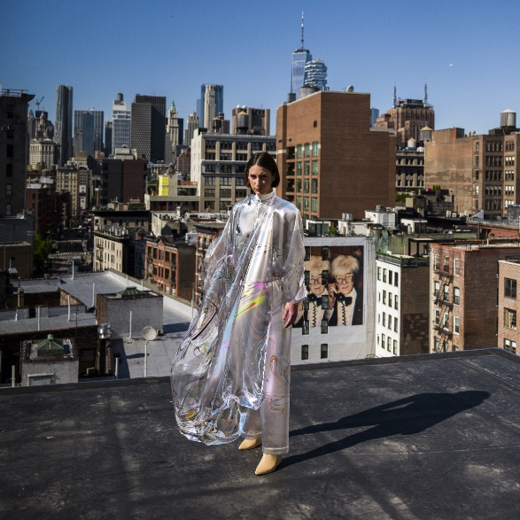 | The Fabricant, Iridescence Dress, 2019
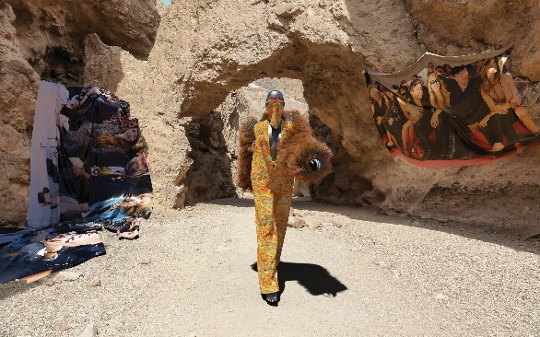 | The Fabricant, DEEP, 2018
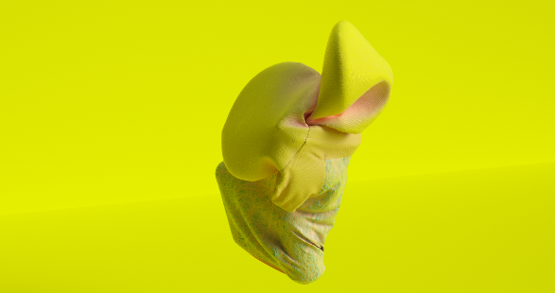 | Zeitguised, Void Season, 2016  g
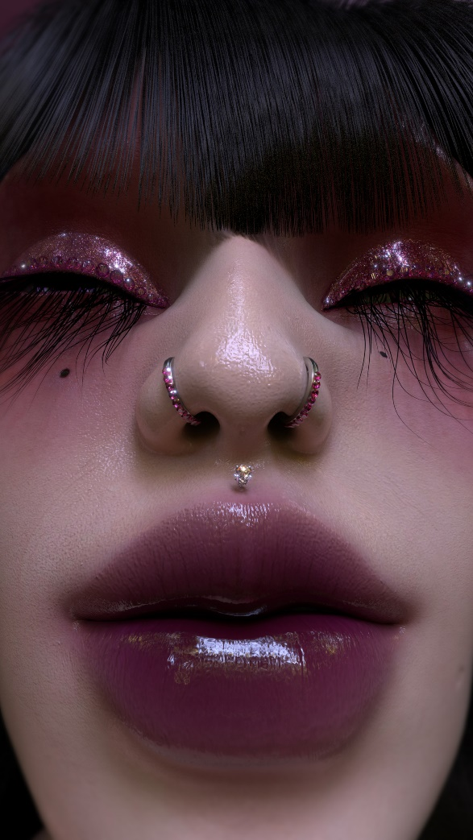 | Carol Civre, CGI-Portret, 2020 (herzien 2022)
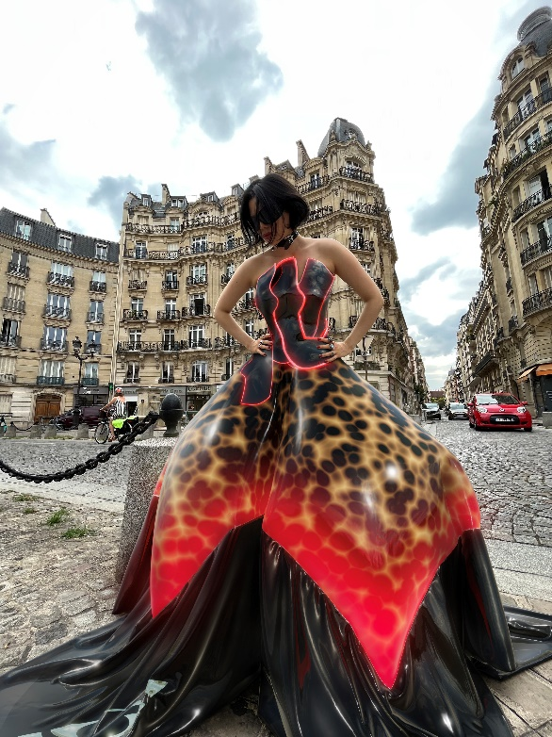 | Tribute Brand, BICA Dress, 2021
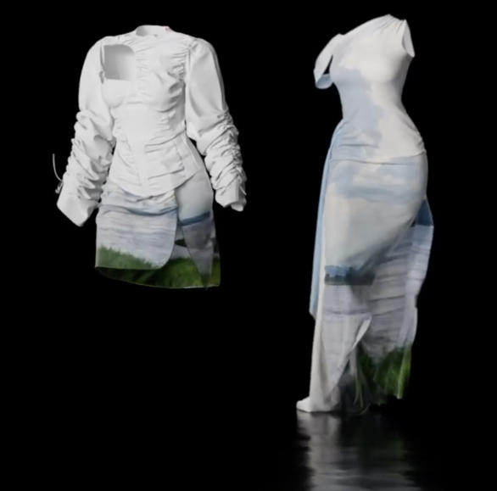 | Hanifa, Pink Label Congo, 2019
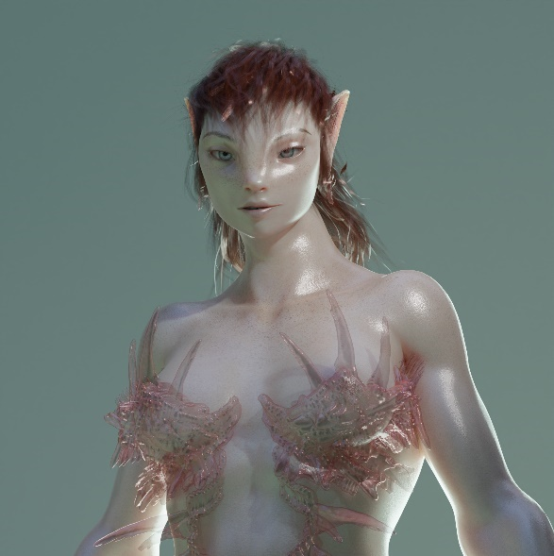 | Harriet Davey, Whowle, 2022
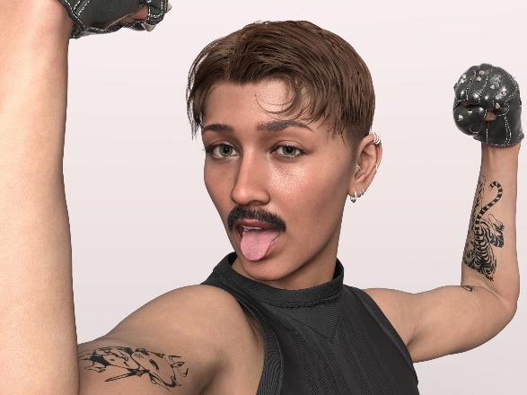 | IoDF X DAZ3D, Catty 8.1, 2022
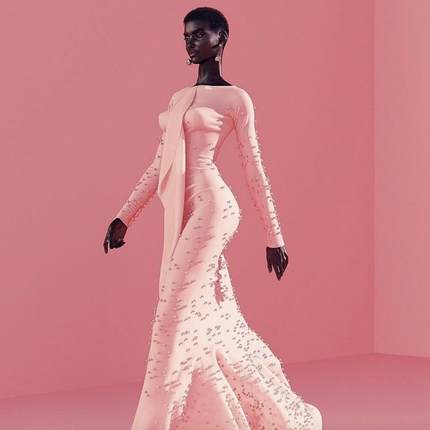 | The Diigitals, Shudu Gram, 2017

